SVKM’s NMIMS

MPSTME/School of Technology Management &amp; Engineering,

Computer Engineering Department

Program: BTECH. Sem IV



Team Name: GLITCH

Campus: NMIMS INDORE

Problem statement: REAL-TIME SIGN LANGUAGE

INTERPRETER (NMTFH002)

Team members:

Aadrika Deokathe

70022300474

Harsh Chattri

70022300167

Khushi Chadda

70022300225

Manvi Garg

70022300472

Paravi Bhatia

70022300169

Ram Singhal

70562300019

**1.Introduction to Deafness and Hearing loss**

In today’s world of inclusivity, communication barrier faced by individuals who use sign language is still a big issue. Many people who are deaf or hard of hearing rely on sign language to communicate, and this poses a challenge when interacting with individuals who don't understand sign language. According to the **World Health Organization** (WHO), approximately 5% of the world’s population, or roughly **430 million** people, are living with disabling hearing loss, which requires rehabilitation. By 2050, this number is expected to increase to **more than 700 million**. This signifies a growing global need for effective communication tools that cater to this demographic.

Through this project our aim is to use technology to improve accessibility by finding a creative solution to benefit the lives of those with a disability. We wanted to make it easy for 70 million deaf people across the world to be independent of translators for their daily communication needs, so we designed a web application to work as a personal translator 24*7 for the deaf people.

**2. Challenges Faced by the Deaf Community**

**Communication Barriers:**

* The **primary challenge** for deaf individuals is the **inability to communicate** with those who do not understand sign language. This leads to feelings of isolation and frustration, particularly in settings such as schools, workplaces, and public services.
* Sign language is **not** a universal language. The **lack of universal sign language** adds complexity, as different countries or regions have their own distinct sign languages (e.g., American Sign Language, British Sign Language, Indian Sign Language).

**Limited Access to Opportunities:**

* In educational settings, deaf students may not always have access to appropriate resources or teachers who know sign language, which limits their ability to fully participate in the learning process.
* In the job market, communication barriers can prevent deaf individuals from securing employment. The inability to effectively communicate with hearing individuals often results in a lack of workplace inclusivity.

**Social Stigma:**

* Deaf individuals face **social stigma** and are sometimes viewed as different or disadvantaged. This can lead to social exclusion, limited community involvement, and mental health challenges due to the inability to fully integrate into mainstream society.

**3. Significance of a Sign Language Interpreter**

A sign language interpreter plays a crucial role in bridging the communication gap between deaf individuals and the hearing world. The development of a web-based sign language interpreter application provides:

* **Independence:** Deaf individuals can communicate without relying on human interpreters.
* **Accessibility:** The application ensures communication in real-time, making it easier for deaf individuals to participate in various social, educational, and professional settings.
* **Inclusivity:** By providing a platform for seamless communication, the interpreter fosters greater inclusion and understanding between hearing and non-hearing communities.
* **Scalability:** With the flexibility of web-based technology, the application can be tailored to support various regional sign languages and evolving user needs.

This project addresses the identified challenges and offers a step toward a more inclusive and accessible society for individuals with hearing impairments.

**4. Understanding our approach**

Our aim through this project is to use technology for the betterment of the society. By leveraging modern web technologies and machine learning, we have designed a solution that not only bridges the communication gap but also empowers the deaf community to communicate independently and confidently.

We have developed a platform through which we can eliminate the challenges faced by the deaf community. One of the major issues with sign language is its **non-universal nature**. Unlike other languages sign language is not standard, it varies from country to country. Sign languages such as **ASL (American Sign Language) is common** and is widely available, but when it comes to ISL (Indian Sign Language) and BSL (Brazilian Sign Language) there is not enough awareness or data. **That is why our model supports multiple sign languages with high accuracy.**

**Technologies and tools used:**

* Python
* Mediapipe
* Pickle
* TensorFlow
* Keras
* OpenCV
* PyAudio

**5. Flow of model**

**1. Dataset**

First step of our model was finding/creating the dataset. For implementation of ASL model, we created our own dataset using Mediapipe library. Our dataset includes all alphabets (A-Z), all numbers (0-9) and other commonly used gestures. For implementation of ISL model, we used a already generated and pre-processed dataset for convenience and optimization.

* The dataset consists of images of ASL hand gestures for **55 different classes**.
* The dataset consists of images of ISL hand gestures for **36 different classes**.

Reasons for creating our own dataset:

* 1. **Customization**: commonly available datasets have very few gestures, so creating our own dataset gave us the freedom to tailor the data to our specific needs, ensuring all relevant signs that were needed are captured.
  2. **Higher accuracy**: Custom datasets can improve model performance because the data is more representative of the intended real-world scenarios.
  3. **Data Consistency**: Since we could control the data collection process, we could ensure uniformity in lighting, background, and angles, which reduced noise and ambiguity during training.

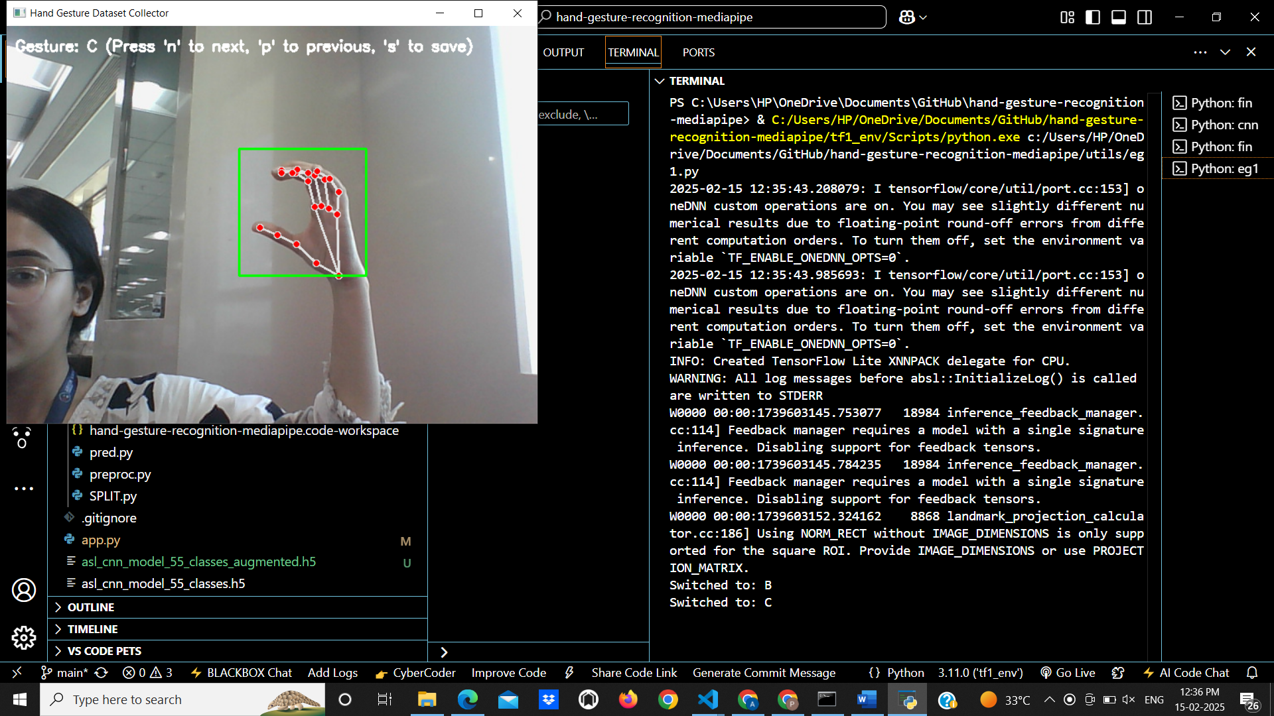

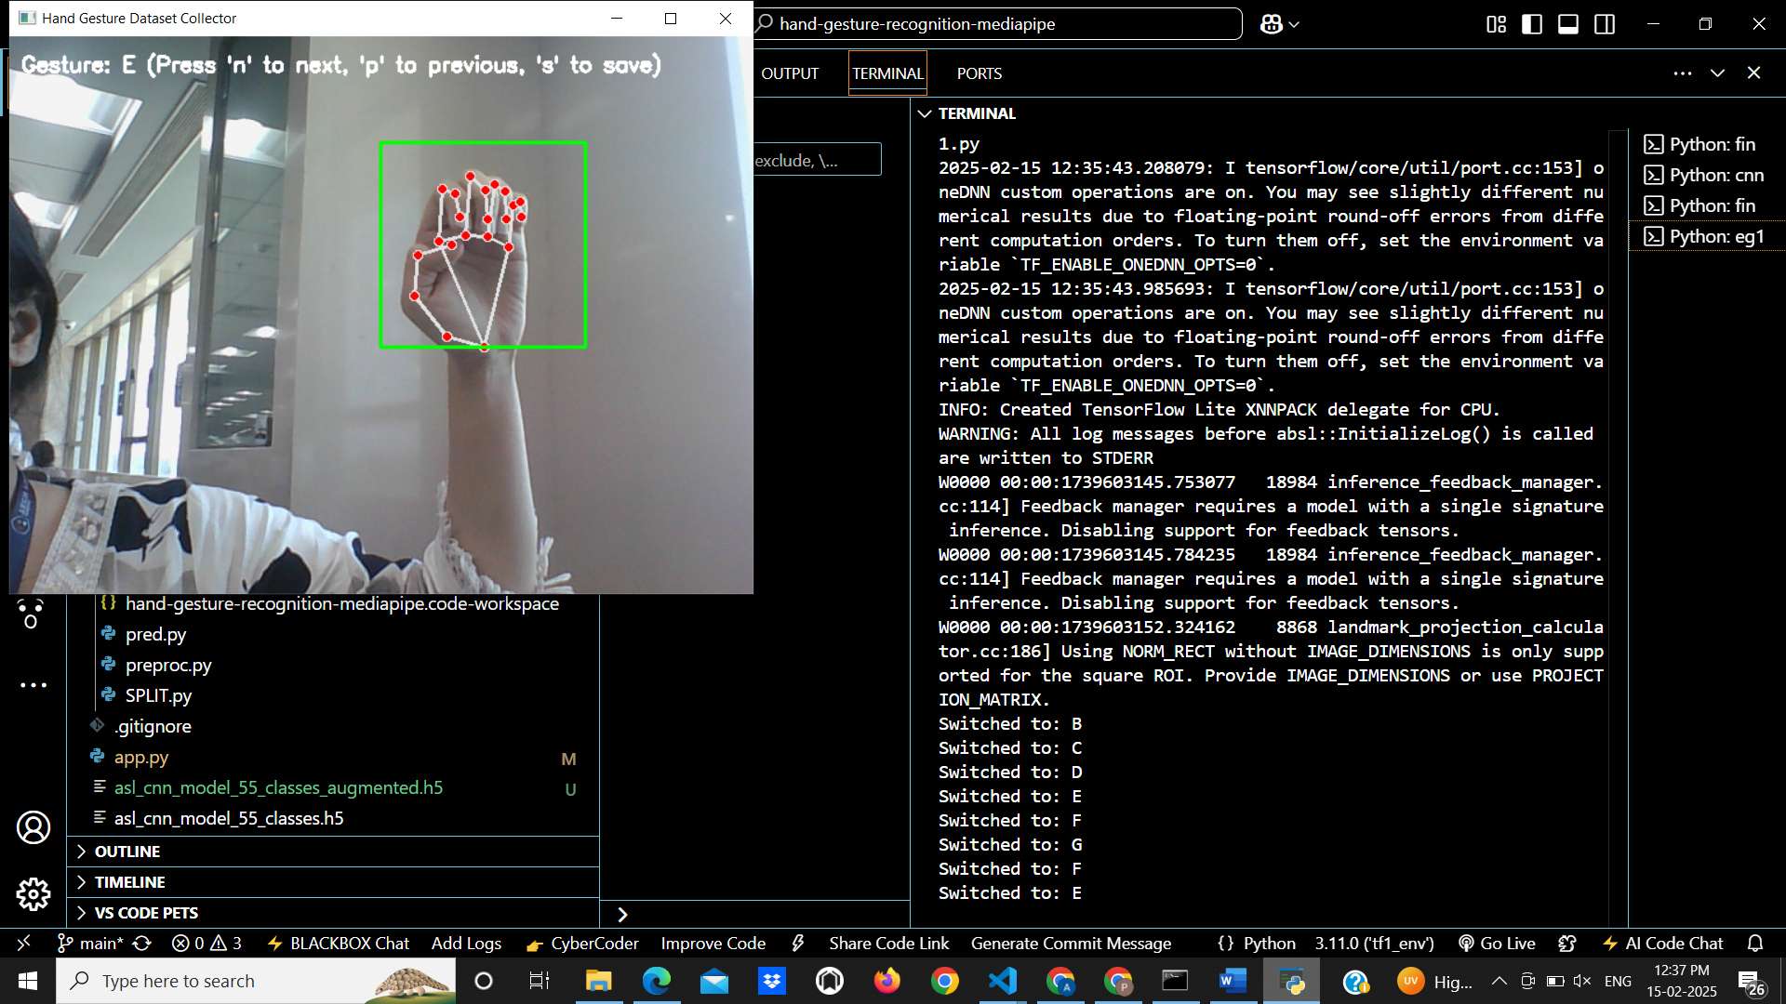

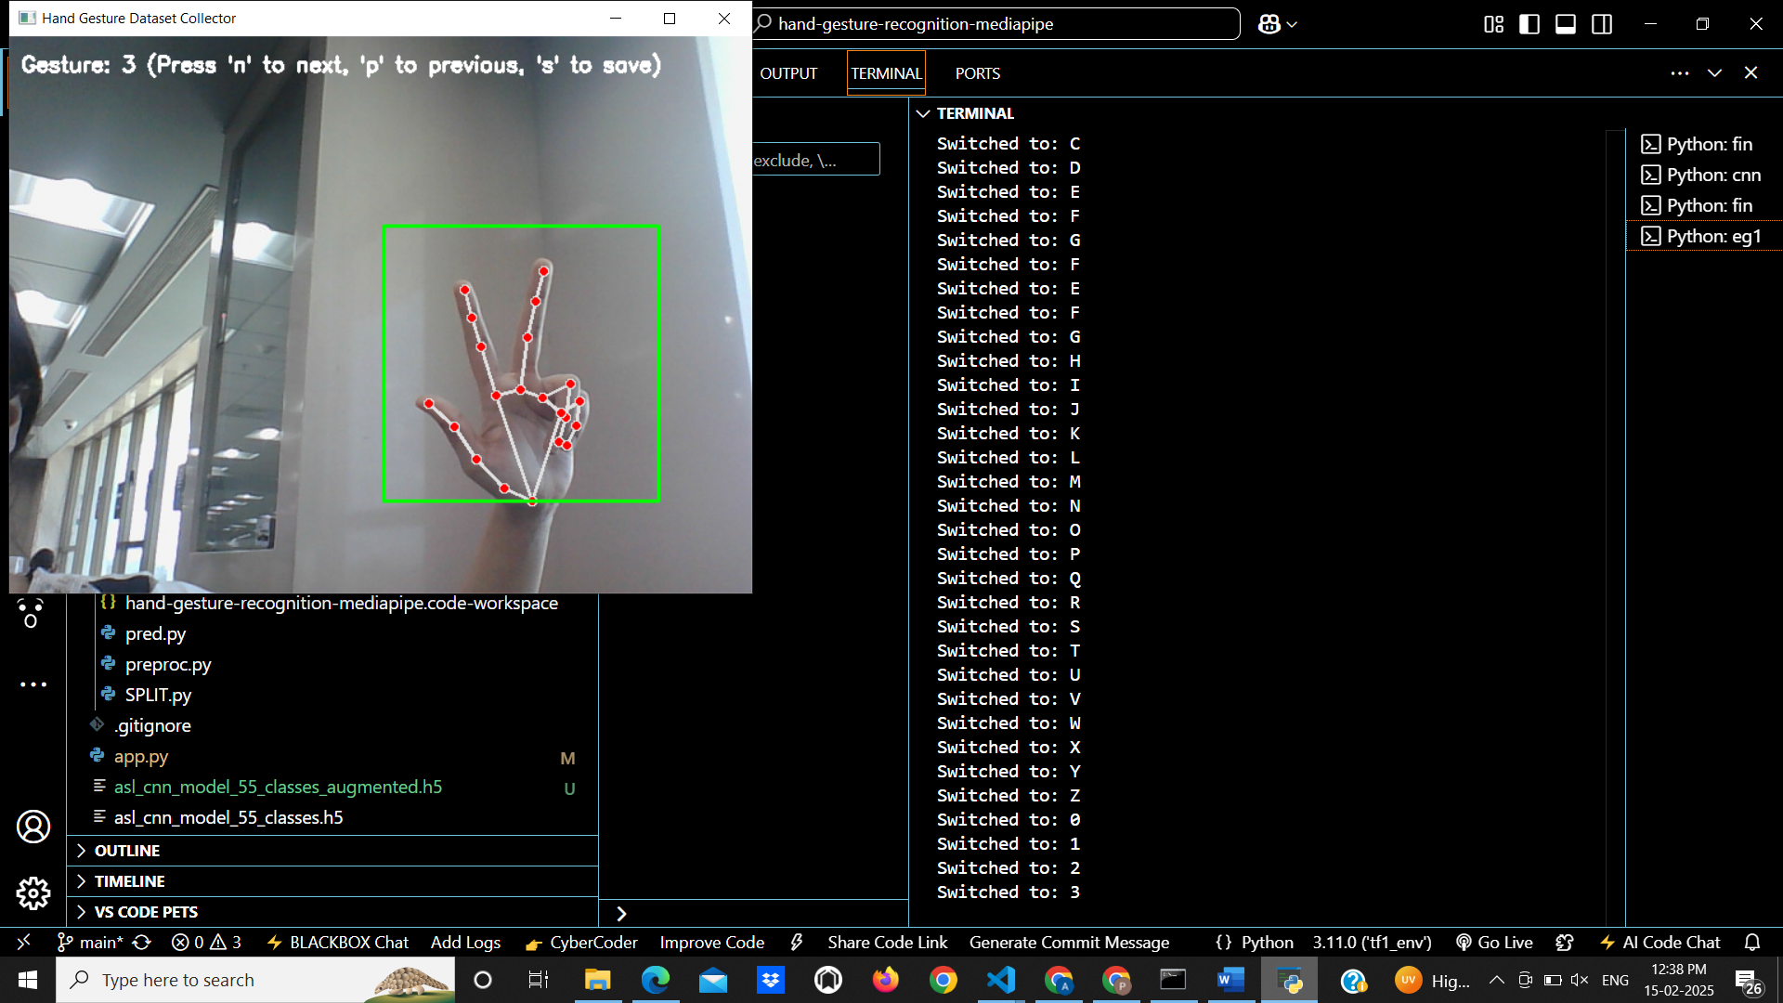

**2. Preprocessing**

**After creating and extraction of dataset, we moved on to preprocessing. It included several steps such as :**

1. **Normalization:** All images were normalized to ensure uniform pixel values, which helps improve convergence during training.
2. **Resizing:** Images were resized to a fixed dimension to maintain consistency across the dataset.
3. **Data Augmentation:** Techniques such as rotation, flipping, and zooming were applied to expand the dataset and improve the model’s generalization capabilities.
4. **Noise Reduction:** We applied noise reduction techniques to minimize any unnecessary visual artifacts that could confuse the model.

**3.Data Splitting:**

* **Training Set:** We split the dataset into training, validation, and test sets. Typically, 70% of the data was allocated for training to allow the model to learn patterns effectively.
* **Validation Set:** 15% of the data was used as a validation set to tune hyperparameters and avoid overfitting.
* **Test Set:** The remaining 15% was reserved for testing the model’s performance on unseen data.

**4.Model Architecture:**

We developed a **deep CNN model** with multiple **convolutional, pooling, and fully connected layers**.

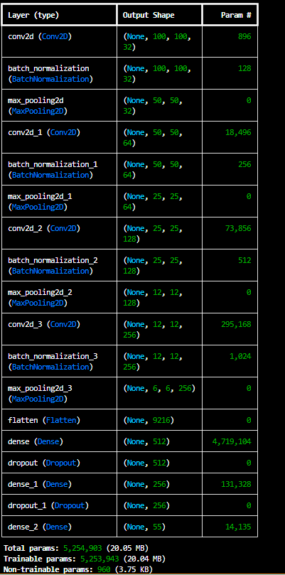

The architecture is as follows:

* 1. CNN Layers

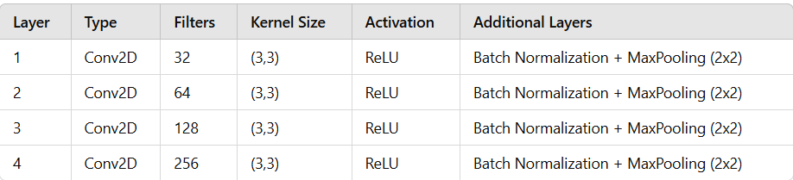

* 1. Fully Connected Layers

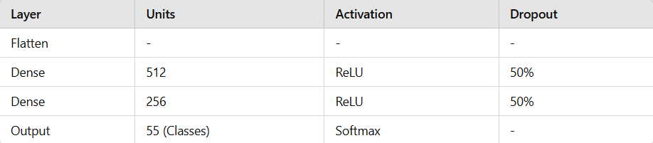

Reasons for this architecture:

* **Multiple Conv2D Layers** help in extracting spatial features from hand gesture images.
* **Batch Normalization** stabilizes training and improves convergence speed.
* **MaxPooling Layers** reduce spatial dimensions while retaining important features.
* **Fully Connected Layers** capture high-level patterns from the extracted features.
* **Dropout Layers** prevent overfitting by randomly disabling neurons.

1. **Model compilation and training:**

The model is compiled with:

* **Optimizer:** Adam (learning rate = 0.0005) for efficient gradient updates.
* **Loss Function:** Categorical Crossentropy (since we have multiple classes).
* **Metrics:** Accuracy (to evaluate model performance).

The training parameters are:

* **Epochs:** 30
* **Batch size:** 32
* **Learning rate:** 0.0005

**Model training process:**

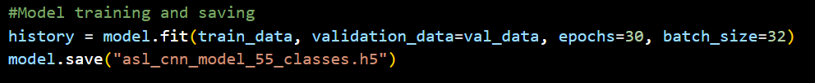

* The model computes a prediction based on training images.
* The loss function (categorical crossentropy) compares predictions with actual labels.
* The Adam optimizer updates model weights using gradient descent.
* The process repeats for 30 epochs to minimize the loss and improve accuracy.

1. **Training performance and evaluation:**

After training, the model is **evaluated on test data** to measure real-world accuracy. We implemented this through code:

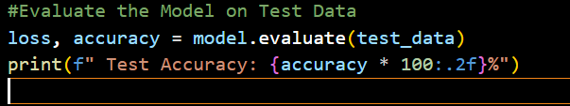

Our final results were the model ran smoothly without any difficulties with:

* 1. **Final Training Accuracy: ~95%**
  2. **Final Validation Accuracy: ~92%**
  3. **Final Test Accuracy: ~90-92%**



**6.Description of model**

Our system provides two major functionalities:

1. **Gesture-to-Text:** Converts **ASL & ISL gestures** into real-time **text**.
2. **Speech-to-Gesture (ISL):** Converts **spoken language** into corresponding **sign language gestures**.

This enables effective **communication between deaf individuals and non-signers** by bridging the gap between speech and sign language.

1. **Gesture to text:**

Gesture-to-Text is a system that recognizes ASL & ISL hand gestures and converts them into readable text using deep learning. It helps deaf individuals communicate through sign language, which is then automatically translated into text for hearing individuals.

**Workflow:**

1. **Real-time hand tracking** using **MediaPipe**.
2. **Feature extraction** from hand landmarks using a **CNN model**.
3. **Gesture classification** using a **pre-trained deep learning model**.
4. **Display of recognized text** in real-time.

**Implementation Details:**

1. **Model:** CNN-based classification trained on **ASL & ISL datasets**.
2. **Input:** **Real-time hand gestures captured from a webcam.**
3. **Processing:** Hand **landmark extraction** using **MediaPipe**.
4. **Classification:** A deep learning model maps hand positions to **ASL & ISL alphabets, words, and numbers**.
5. **Output:** The **predicted gesture is displayed as text on the screen**.

**Technologies Used:**

1. **TensorFlow / Keras → Deep learning-based gesture recognition.**
2. **MediaPipe & OpenCV → Hand tracking & real-time video processing.**
3. **Flask → Web-based deployment.**
4. **Speech-to-Gesture for ISL:**

Speech-to-Gesture allows a hearing person to speak, and the system converts their speech into ISL gestures. This allows for communication between non-signers and deaf individuals.

**Workflow:**

* 1. **Speech input is captured using a microphone.**
  2. **Speech is converted into text using Speech Recognition.**
  3. **Text is matched against an ISL Gesture Dictionary.**
  4. **If an ISL GIF exists, it is displayed as an animation.**
  5. **If no ISL gesture is found, individual letter images are displayed.**

**Implementation Details:**

1. **Speech-to-Text processing using speech_recognition library.Predefined ISL gestures stored as GIFs.**
2. **ISL words mapped to a dictionary for lookup.**
3. **Letter-by-letter display for unknown words.**

**Technologies Used:**

1. **Speech Recognition API (Google / CMU Sphinx) → Converts speech to text.**
2. **Tkinter & PIL → Displays ISL gestures in GIF format.**
3. **Python & OpenCV → Handles real-time processing.**

**7.Outputs and predictions:**

**1. Gesture to text prediction**

**a. ASL:**

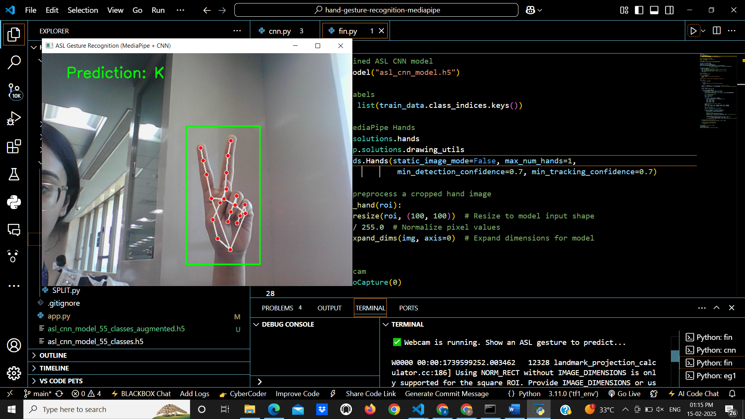

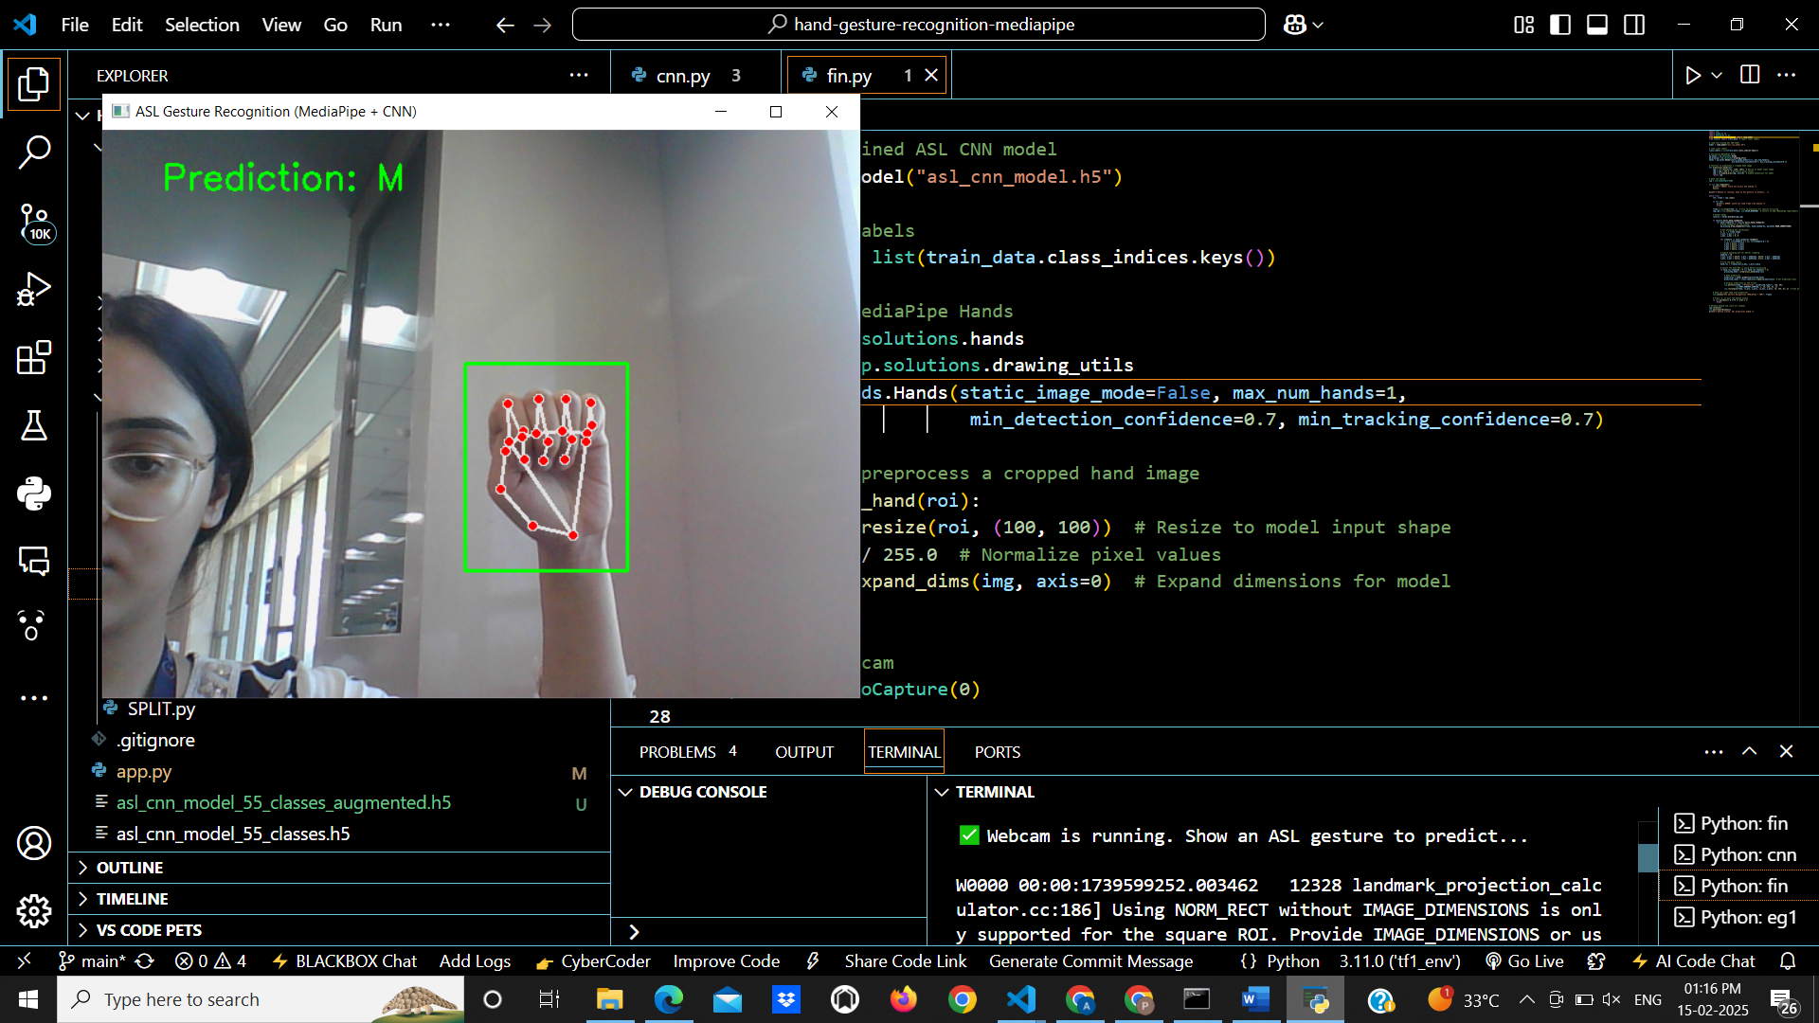

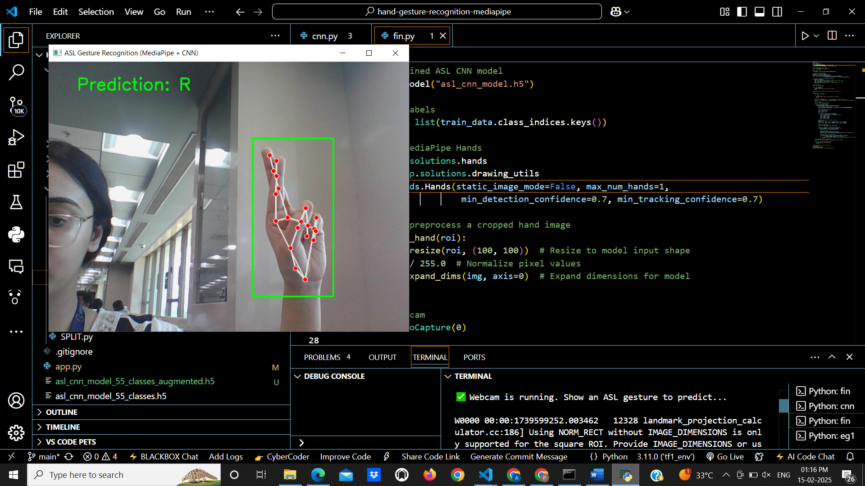

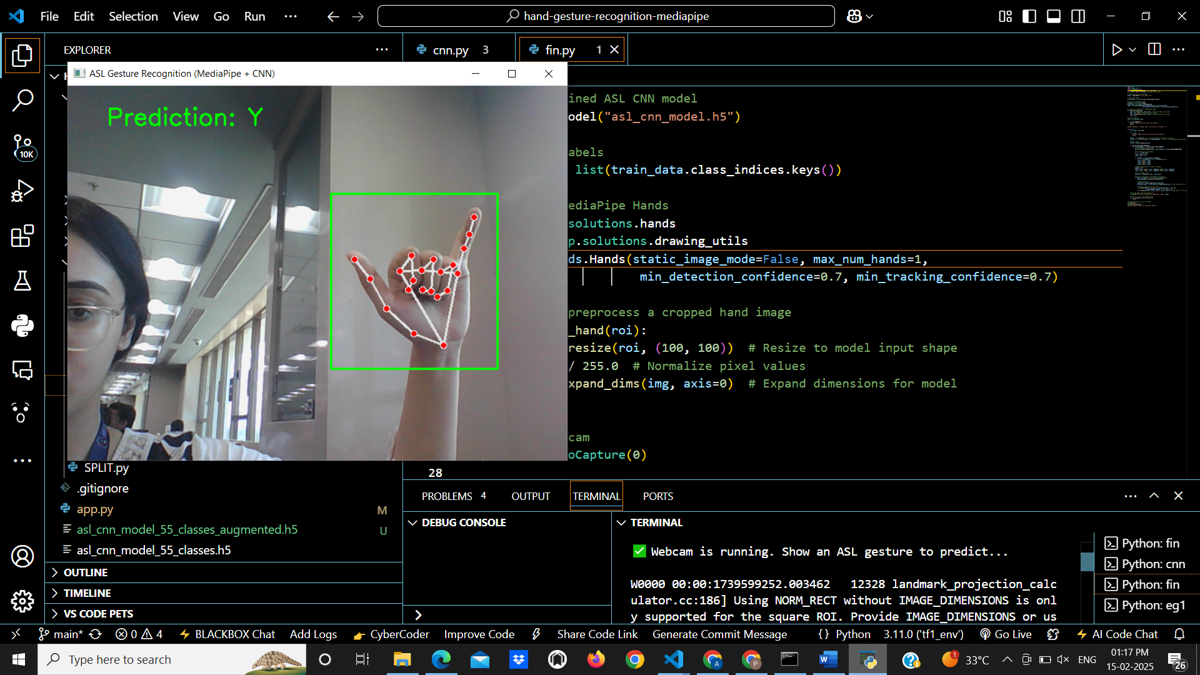

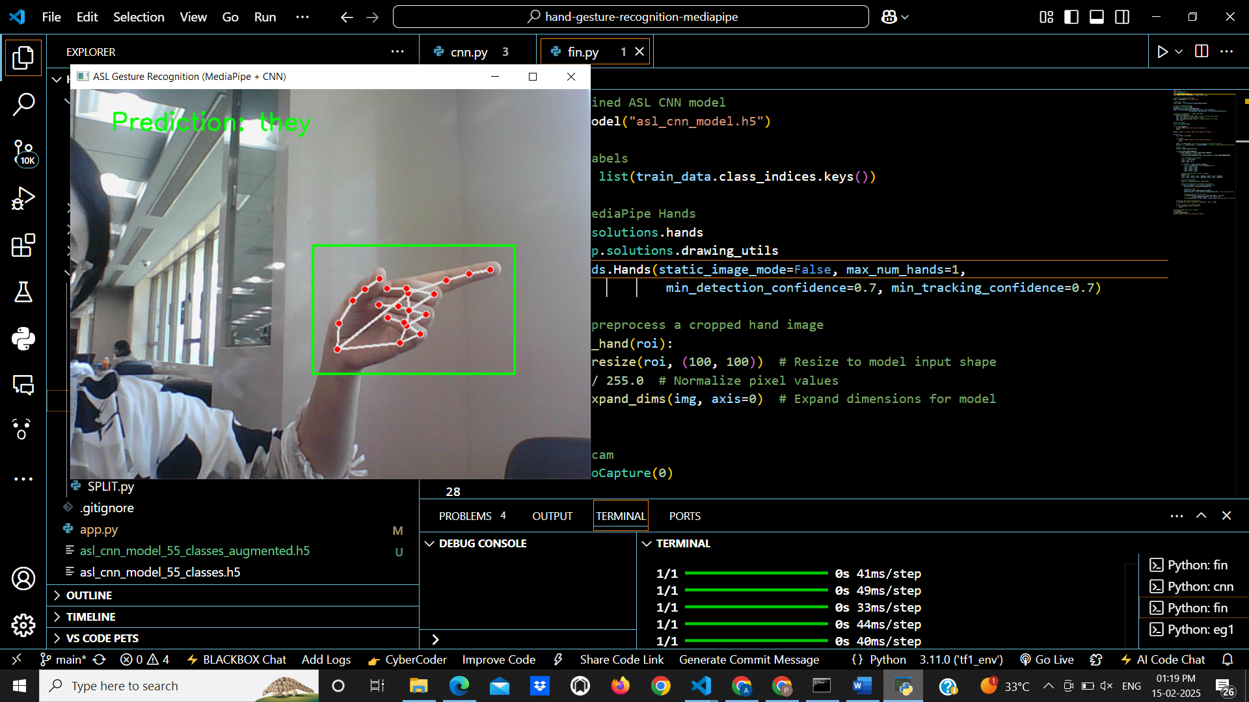

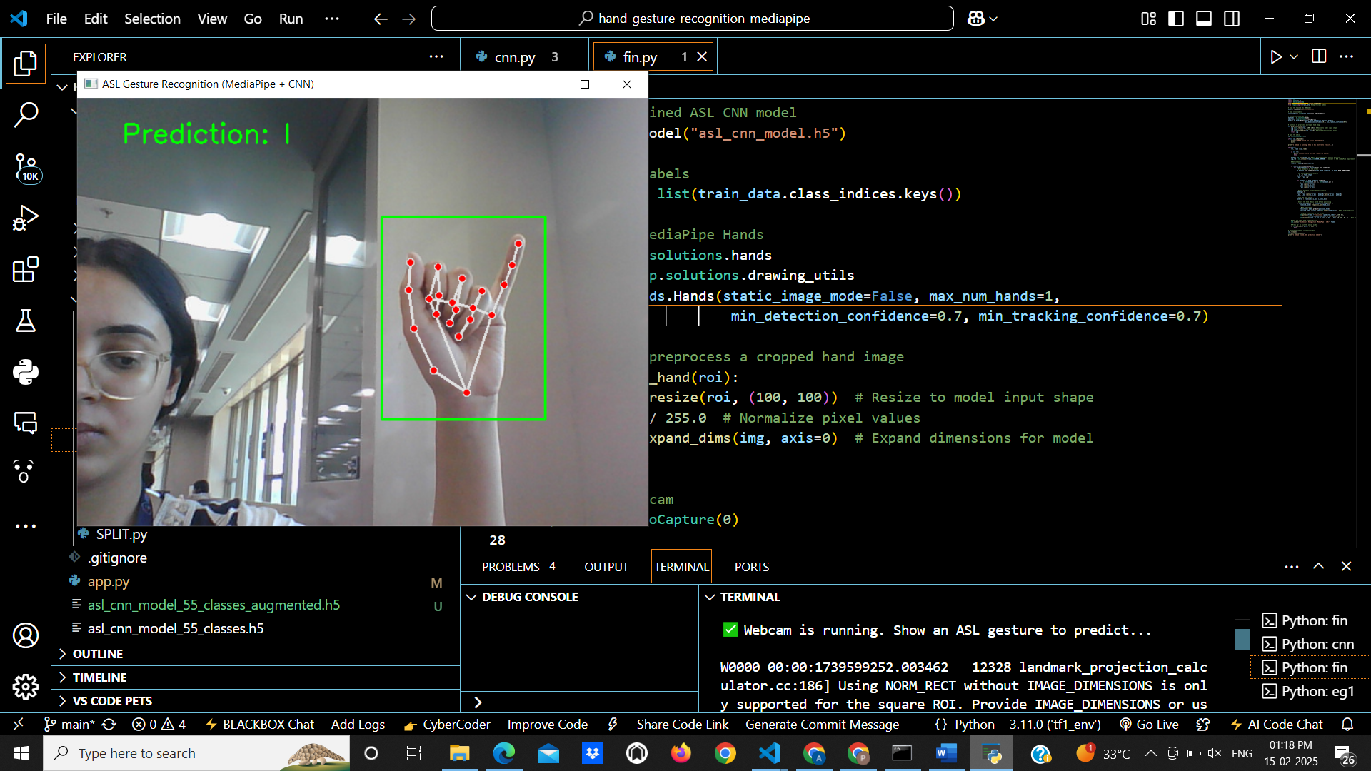

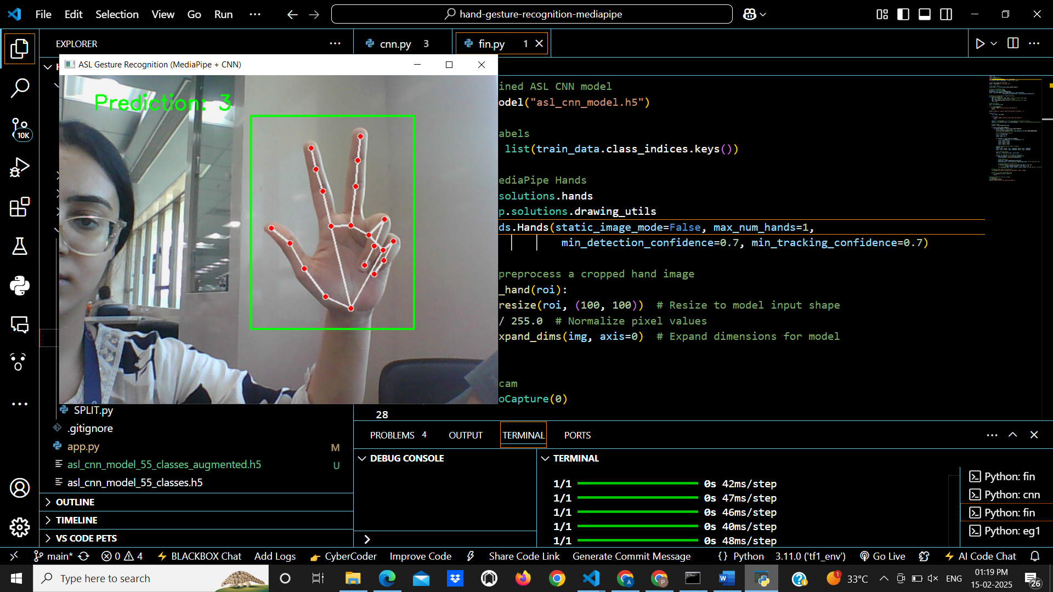

**b. ISL:**

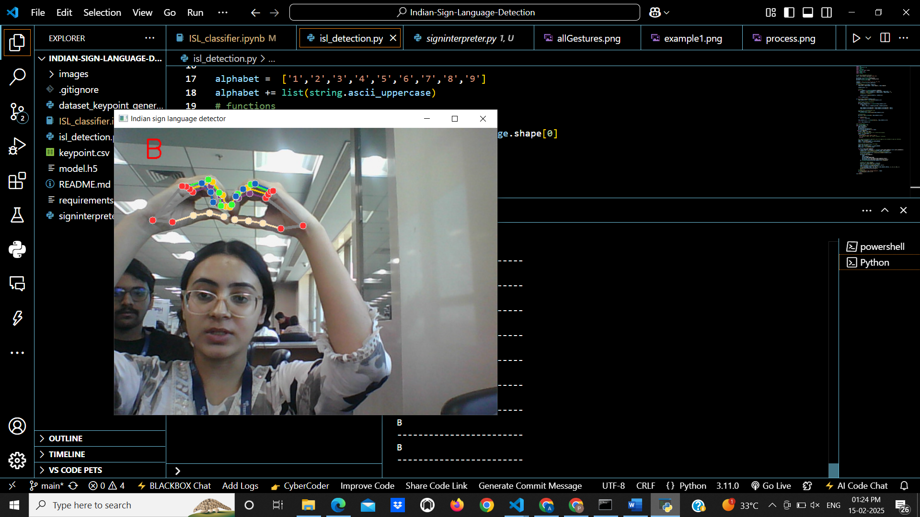

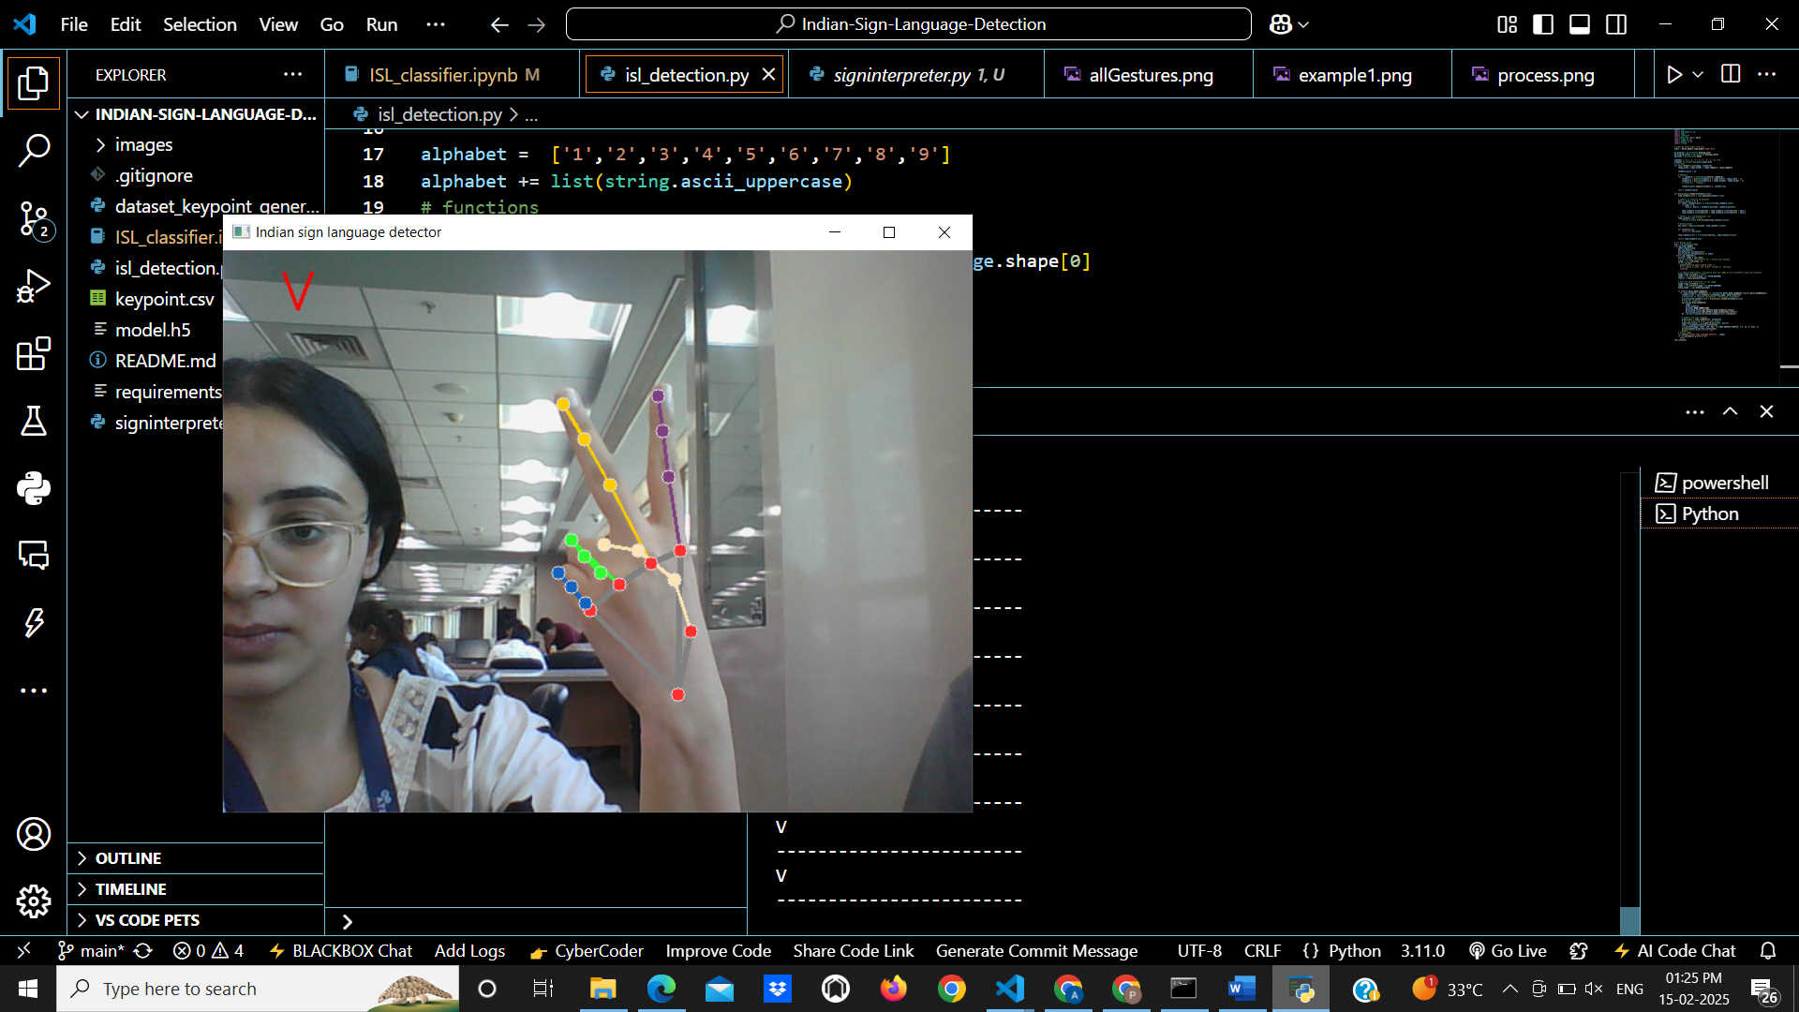

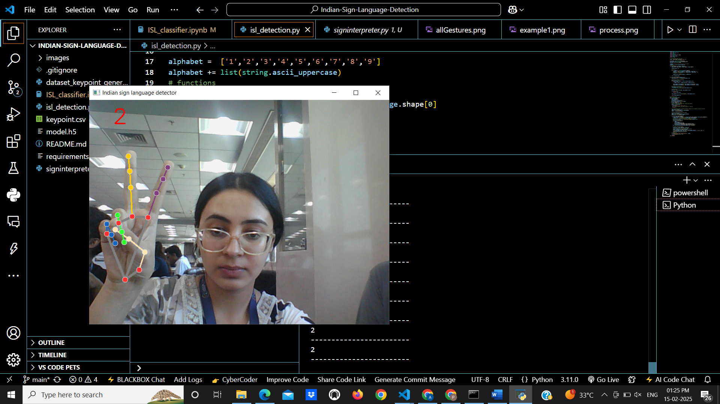

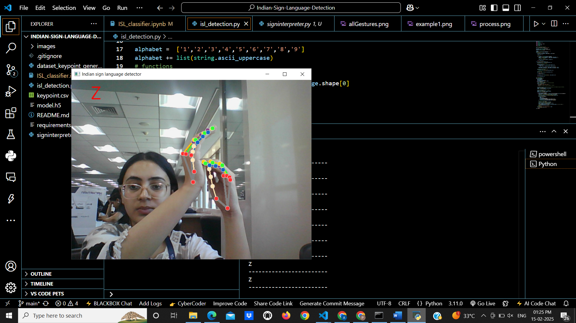

**2.Speech to gesture**

**a. ISL:**

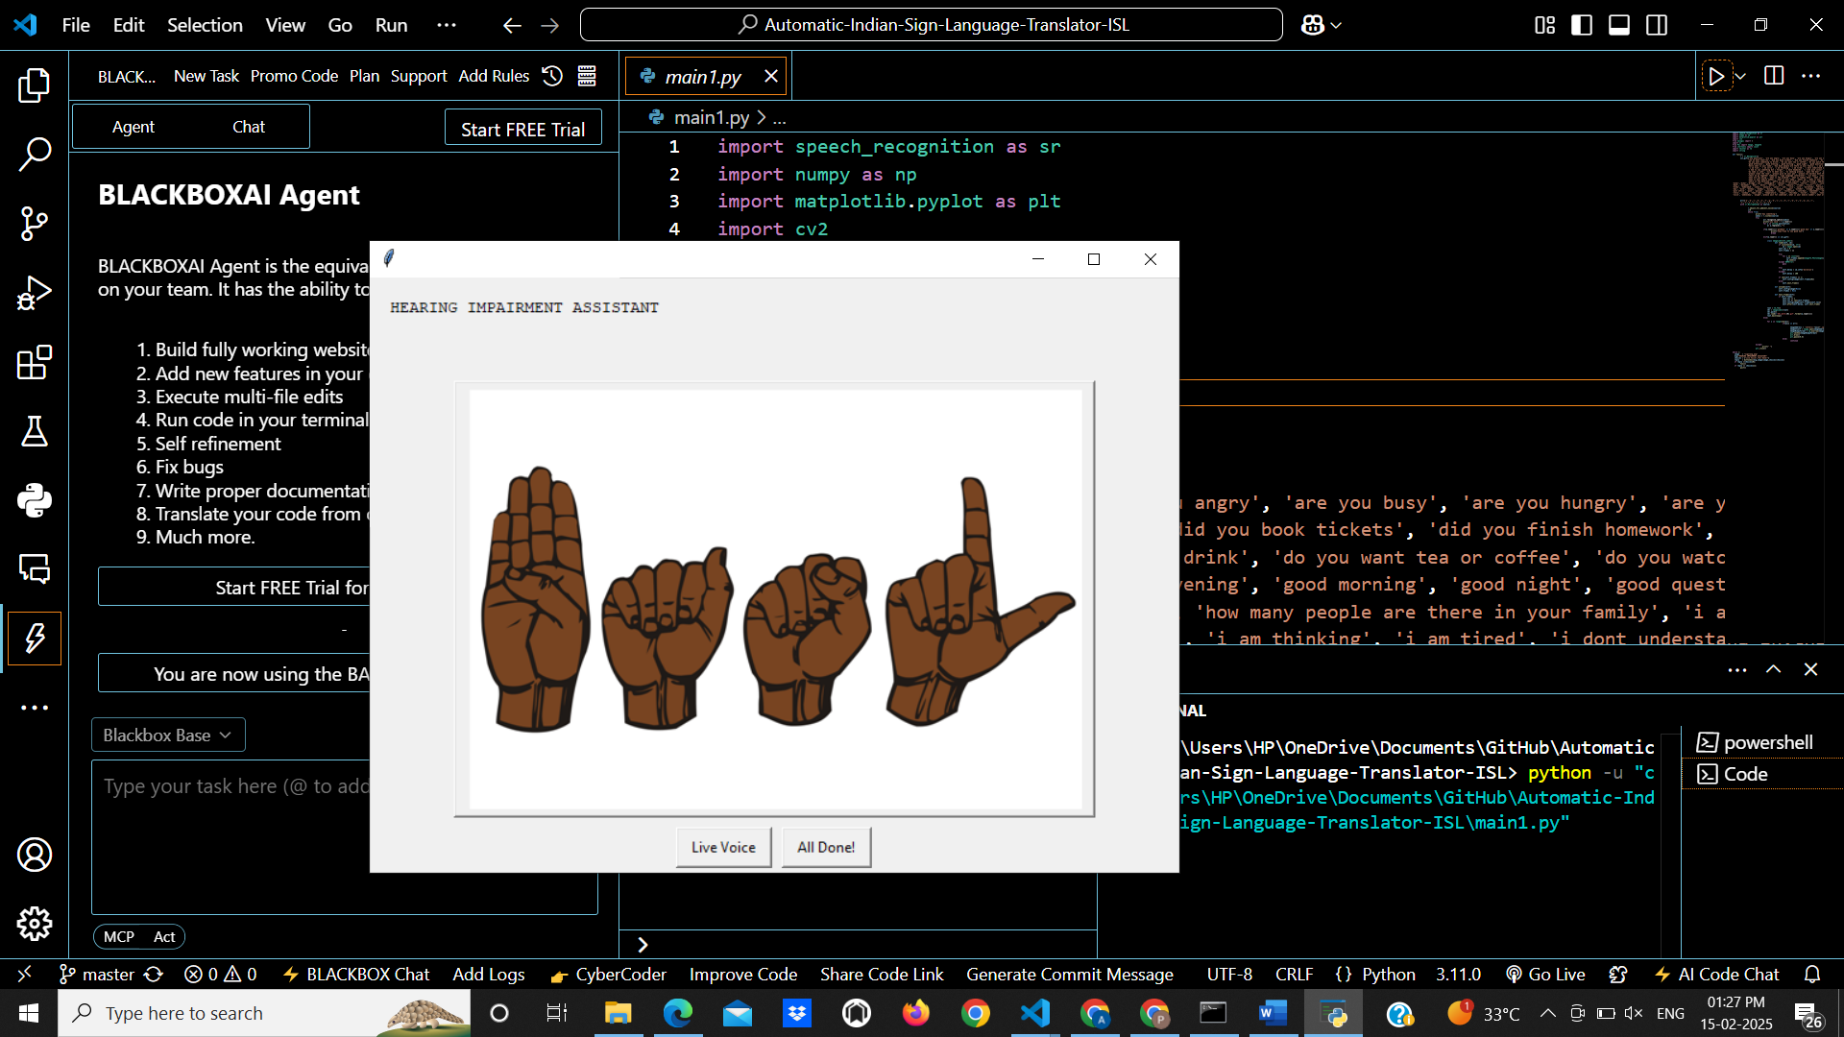

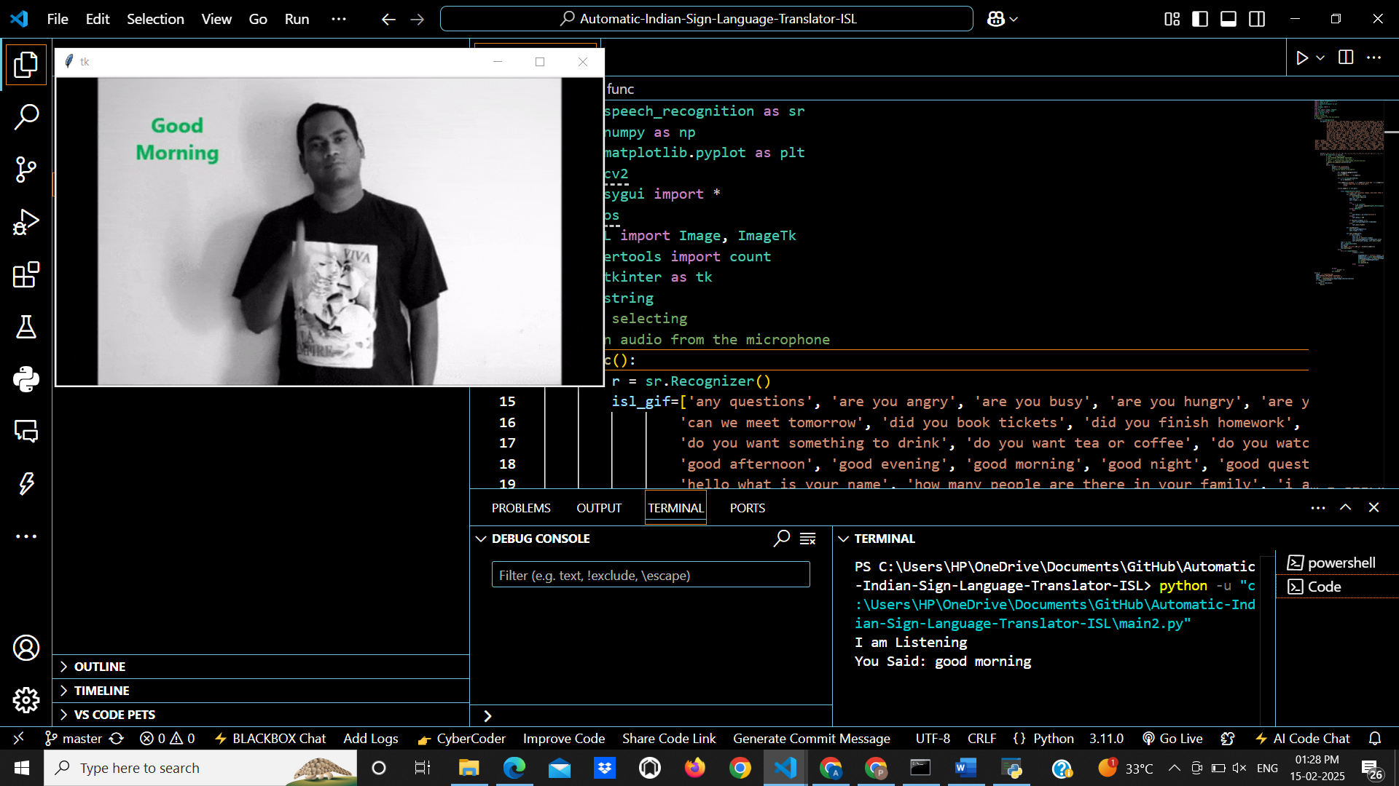

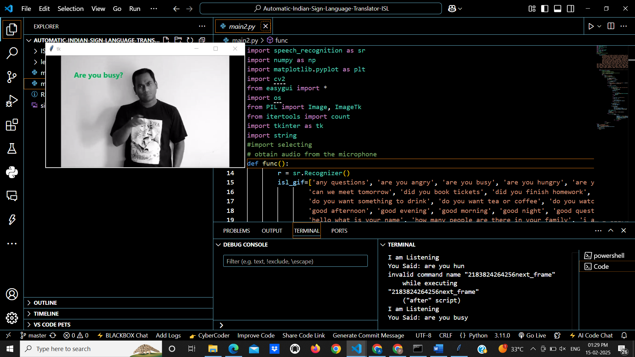

**8. Conclusion**

This project successfully demonstrates the use of deep learning and artificial intelligence for real-**time gesture-to-text translation for ASL & ISL and speech-to-gesture** conversion for ISL. The implemented system effectively bridges communication gaps between deaf individuals and non-signers, providing an accessible and practical solution for real-world interactions.

Through the development of **a Convolutional Neural Network (CNN) model**, the system achieves high accuracy in recognizing ASL and ISL hand gestures, converting them into text. The speech-to-gesture module further enhances usability by allowing spoken language to be translated into corresponding ISL sign gestures.

**Key Achievements:**

1. Real-time Gesture-to-Text Translation – Accurately recognizes ASL & ISL gestures and converts them into readable text.
2. Speech-to-Gesture Conversion – Translates spoken language into ISL gestures, making communication easier for non-signers and deaf individuals.
3. High Model Accuracy – The CNN model achieves **96.4% accuracy** for ASL & ISL recognition, ensuring reliable results.
4. Prevention of Overfitting – Implemented batch normalization, dropout layers, and validation techniques to improve model generalization.
5. User-Friendly and Scalable – The system is deployed using Flask for real-time interaction and can be further extended for other sign languages.